Bharathiar University
Coimbatore- 641 046, Tamilnadu, India
Accredited with “A++” Grade by NAAC | Ranked 15th among Indian Universities by MoE-NIRF

Steps for Applying PG/UG ADMISSION FOR THE ACADEMIC YEAR 2024 - 25

Instructions to fill up the PG and UG Application Form through Online
- Applicants are requested to read the Information Brochure carefully and completely regarding eligibility for admission of programmes before filling the application form.
- Before filling the online application, ensure the availability of digital form (soft copy) of the following documents:
  - 10th Mark Sheet, 12th Mark Sheet, UG Marks Statements of all the semester (Those who are studying sixth semester have to attach first 5 semester mark statements), Consolidated Mark Sheet, Provisional Certificate, Degree Certificate, Community Certificate, Special Category Certificate in PDF file format only. Maximum File Size Should be 200 kb
  - A Passport Size Photograph of the applicant (“JPEG"/”PNG”/”JPG” format) is required. Photo Field accept only JPG, JPEG, PNG format files Only. Maximum File Size Should be 200 kb
  - Applicant’s signature using Blue/Black pen on white sheet (“JPEG"/”PNG”/”JPG”
format). Signature Field accept only JPG, JPEG, PNG format files Only. Maximum File Size Should be 50 kb
- A valid E-mail Id is mandatory to submit the application and further to receive all correspondence regarding the admission process. If the applicant already registered with any other course in Bharathiar University for Admission 2024-25 using the same email id, the applicant receives the error message “Email id already registered”. In this case the applicant should use the different email id to register as a new user.
- The applicants interested in admissions to different departments of Bharathiar University will have to apply separately for each course. They will also have to pay the application fee separately for each course.

- Application Fee payment should be done only through Online mode through application portal for the payment.
- After the successful submission of application through online, applicants are requested to send the hard copy of downloaded application to the concerned Head of the Department, Bharathiar University, Coimbatore - 641046.
- The fields marked as “*” are mandatory which has to be filled without fail while filling up the application form.
- Applicants those who are applying for M.Ed. Programme should enter their B.Ed. Mark statement details in the place of UG marks in the qualification details.
- If the applicant filled under sports quota - the relevant document must be uploaded without fail.
- If any queries, kindly send a mail to buadmission@buc.edu.in, or through query response system https://erp1.b-u.ac.in/erp/support1/login
- After submission of the application in the admission portal the hardcopy of the application along with the marksheets of 10th, 12th, UG Semester Marks Statements (1st -5th Semester), Community Certificate, and Special Category Certificate (if any), has to be sent through post to the following address.
Pls mention the cover as “PG Admission - Application”
To  The Head of the Department  Name of the dept. (application submitted)  Bharathiar University, Coimbatore-46  Tamilnadu, India. | To (Sample)  The Head of the Department  Department of Computer Applications  Bharathiar University, Coimbatore-46  Tamilnadu, India.

- Last Date for submission of application form is on or before 0.06.2024.

ONLINE REGISTRATION

- Step1 : Register as user by clicking New Registration New Registration
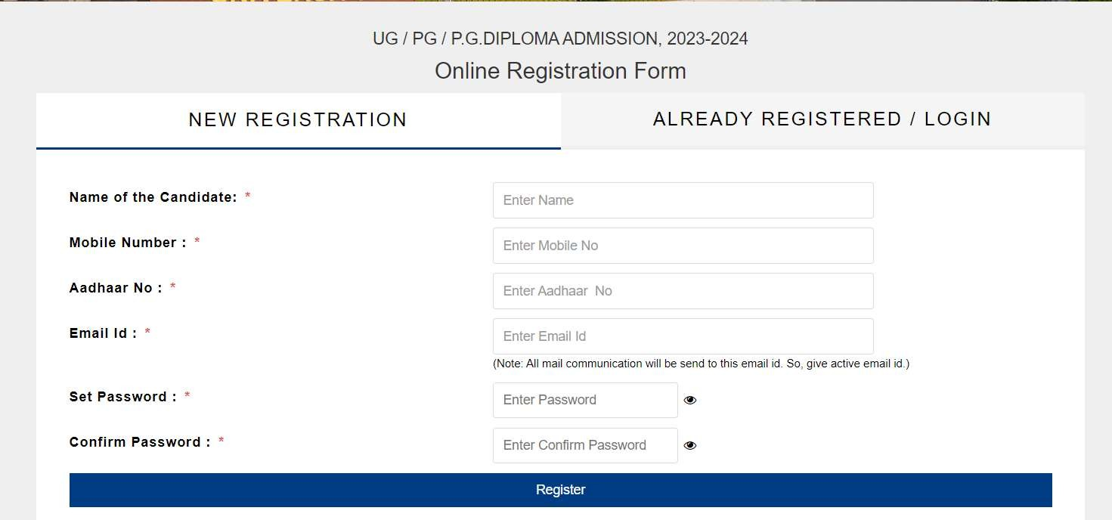

- Step 2: Login using the Registerd emailid by clicking Login / Already Registered
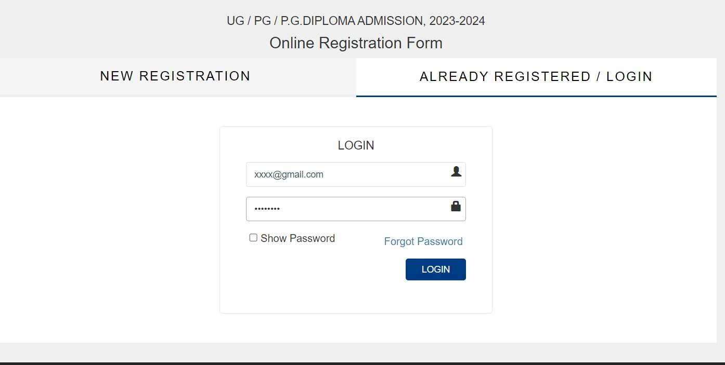

- Step 3: Reset Password if password has to be changed by clicking
(Type the email for which password reset link has to be shared )
Forgot Password
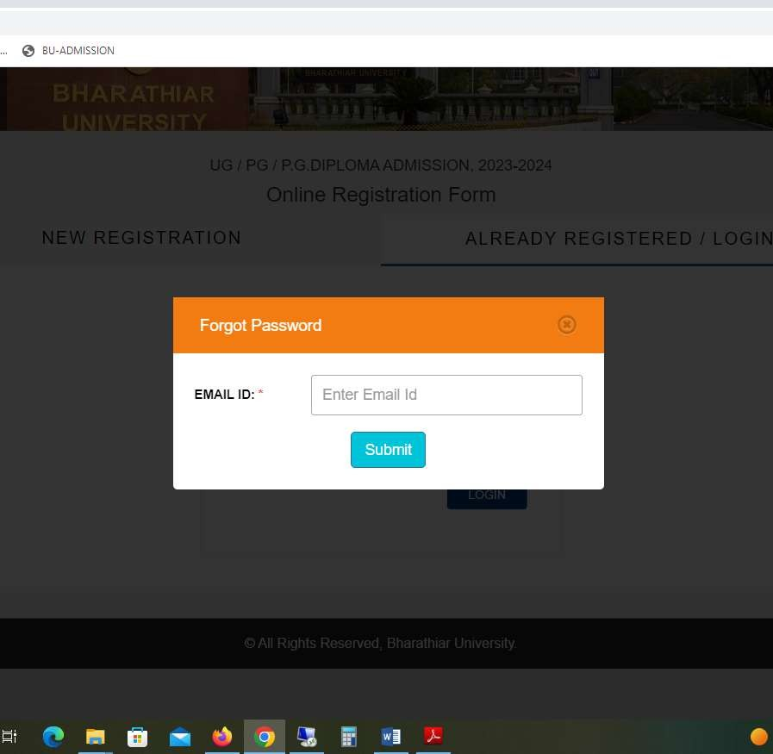

- Step 4 : Admission Registration Form Page
Select Basic Details to enter - Enter Basic Details and save the data

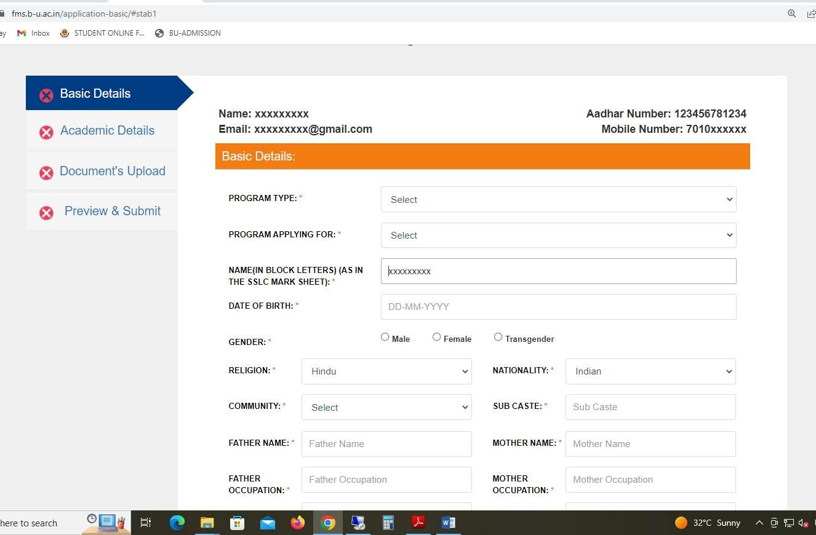

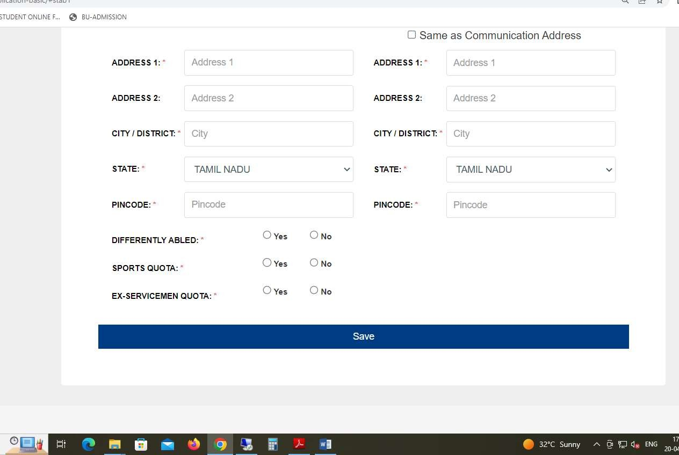

- Step 5: Click Academic Details to enter academic marks
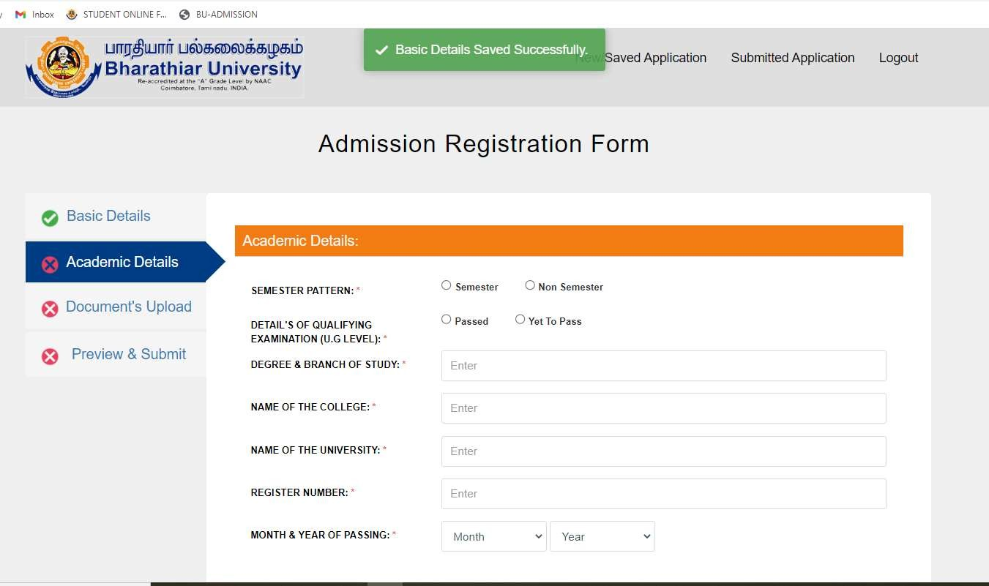

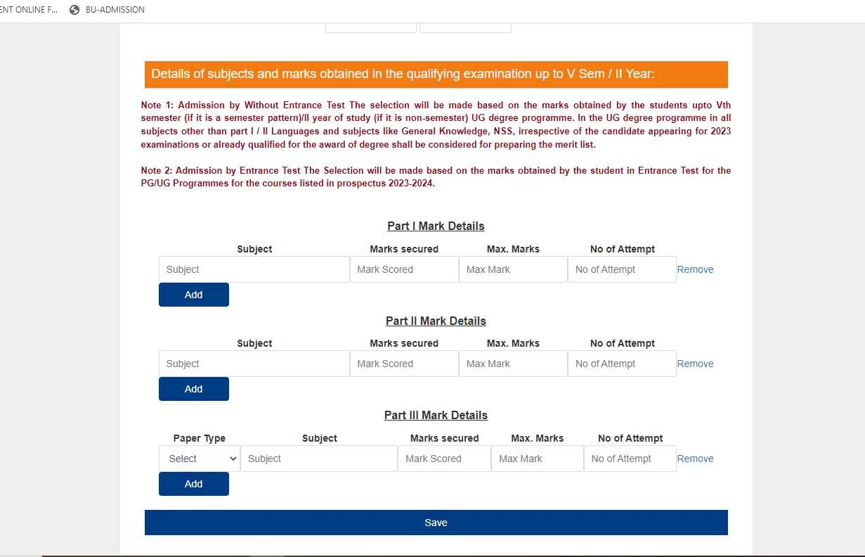

- Step 6: Upload Document’s
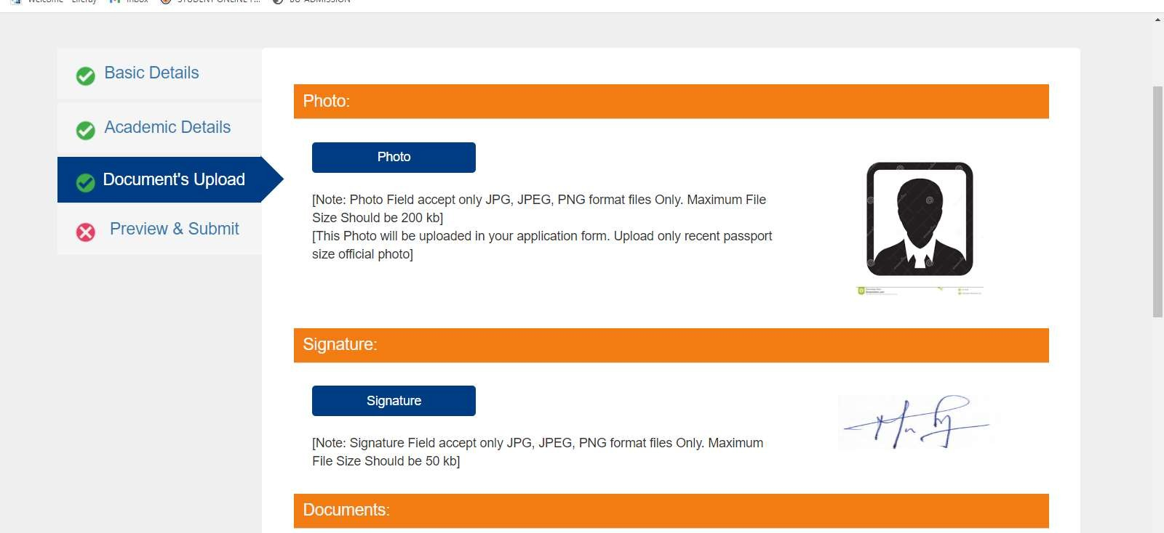

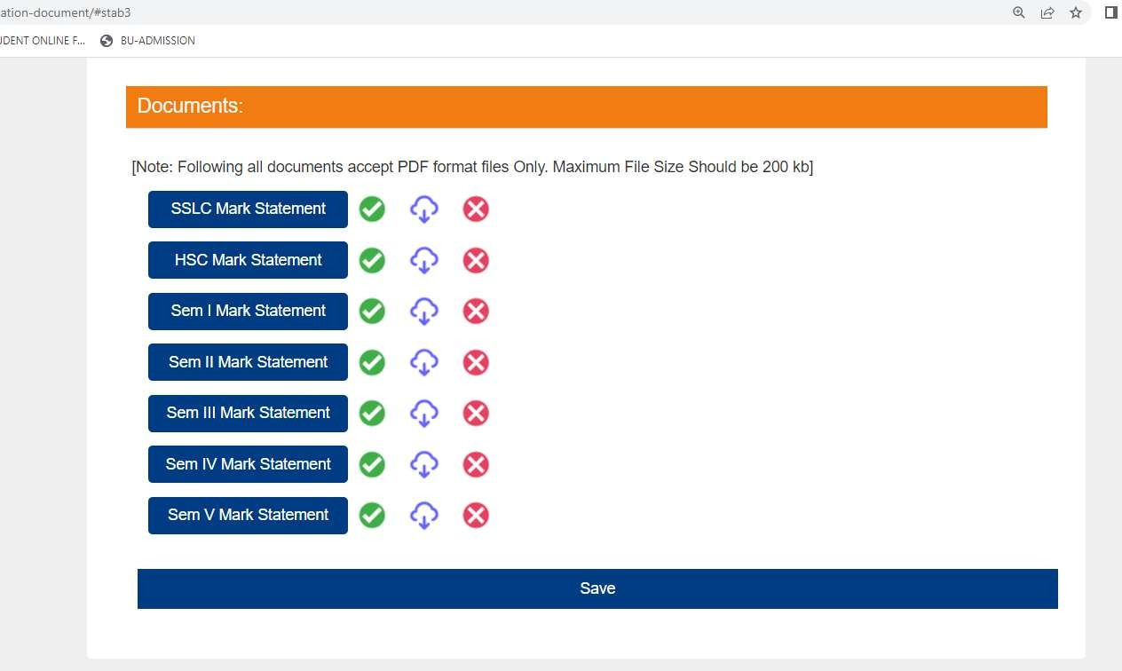

- Step 7: Preview & Submit
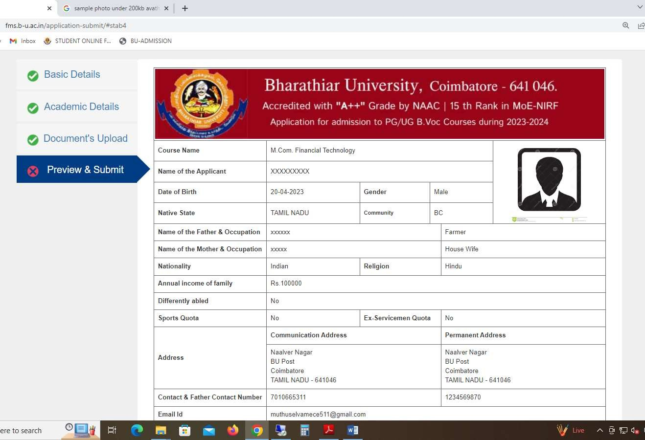

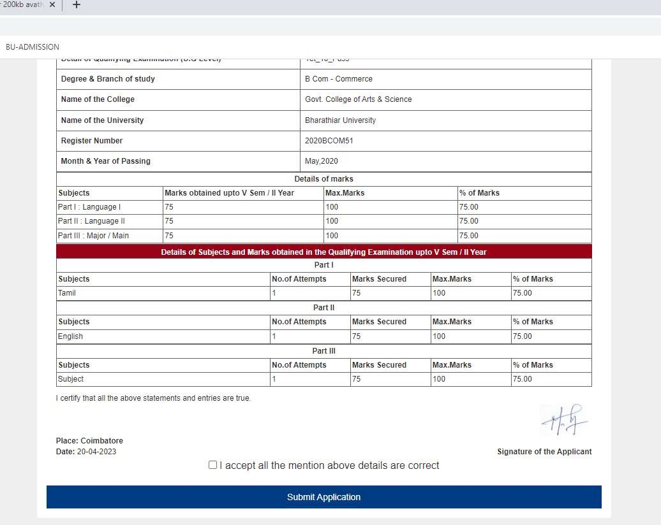

- Step 8: Payment Page
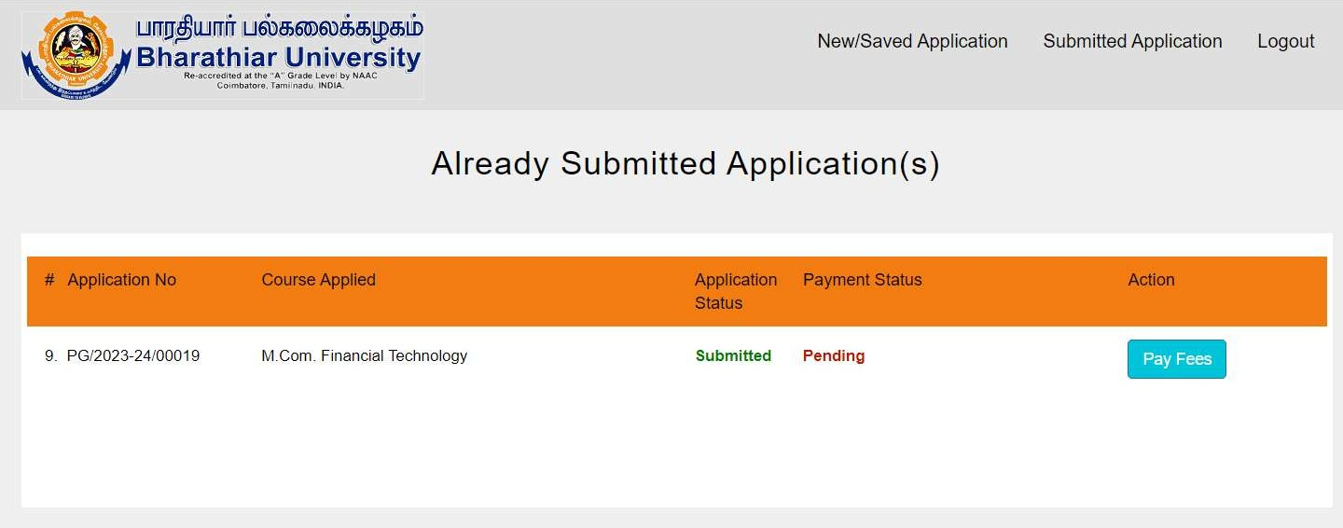

- Step 9: Choose Online Payment Modes
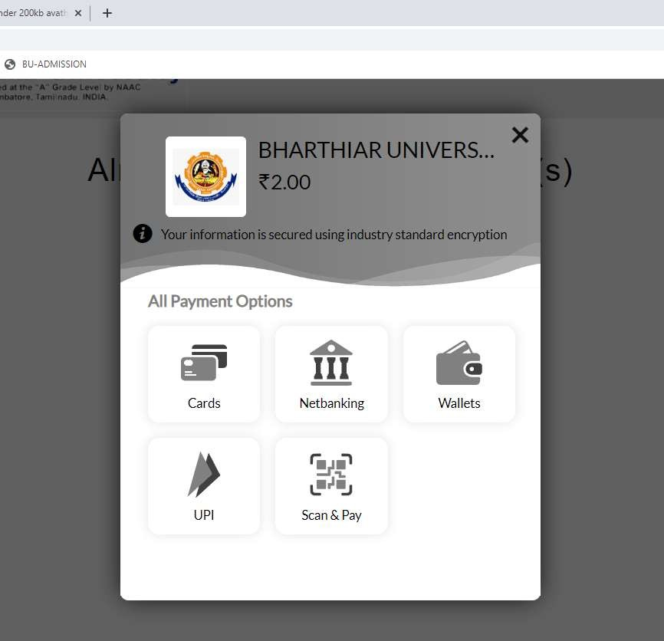

- Step 10 : After payment download Application
