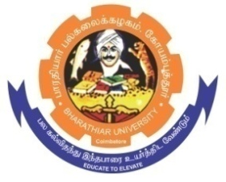
ghujpahh; gy;fiyf;fHfk;
BHARATHIAR UNIVERSITY
COIMBATORE – 641 046, TAMILNADU, INDIA

State University | Re-Accredited with “A++” Grade by NAAC | Ranked 21st among Indian Universities by MHRD-NIRF

TENDER INVITING NOTICE

E-Tender Notice No: BU/R-D2/Nano/Equip/3417/2023-24 Date: 14.03.2024

Online Bids are invited through Tamil Nadu Government e-Procurement Portal website:
www.tntenders.gov.in Tenders by Organisation Higher Education for the purchase of 1 No. of Co-Oxial spinneret additional spare part for already exiting Electrospinning unit for the Department of Nanoscience and Technology in Bharathiar University, Coimbatore.
The Tender documents can be downloaded from 14.03.2024. Bid submission will be started on 14.03.2024 and will be closed on 01.04.2024 @ 3.00PM.

REGISTRAR i/c.

Website: www.b-u.ac.in ٭ E-Mail: regr@buc.edu.in ٭ Phone: 0422-2428108/2428126 ٭Fax: +91 422 2425706

